Monitoring Jobs to be Invoiced

This applies to –
- Exports with a departure date in the current month.
- Imports with an arrival date in the current month.
Proceed to the dashboards/filters within Shipments and Customs Declarations to identify current period jobs.
Refer to the ETA date or ETD date (depending on whether you are checking import or export shipments), then identify what is still pending for invoicing or CMP.
By month end closing, all billable jobs for the current month must be updated to CMP status.

This can only be done if the following conditions are met –
- All expected costs are accrued in accordance with agreed buy rates.
- All expected sell components are invoiced in accordance with agreed sell rates.
- If further amounts are still be invoiced and cannot be done within the current period, then invoicing status is to be updated to IHL. Any associated communication is to be saved within the job for future reference.

- Following example demonstrates the S Jobs/Import FCL listing, although all other modes and directions are also to be checked.

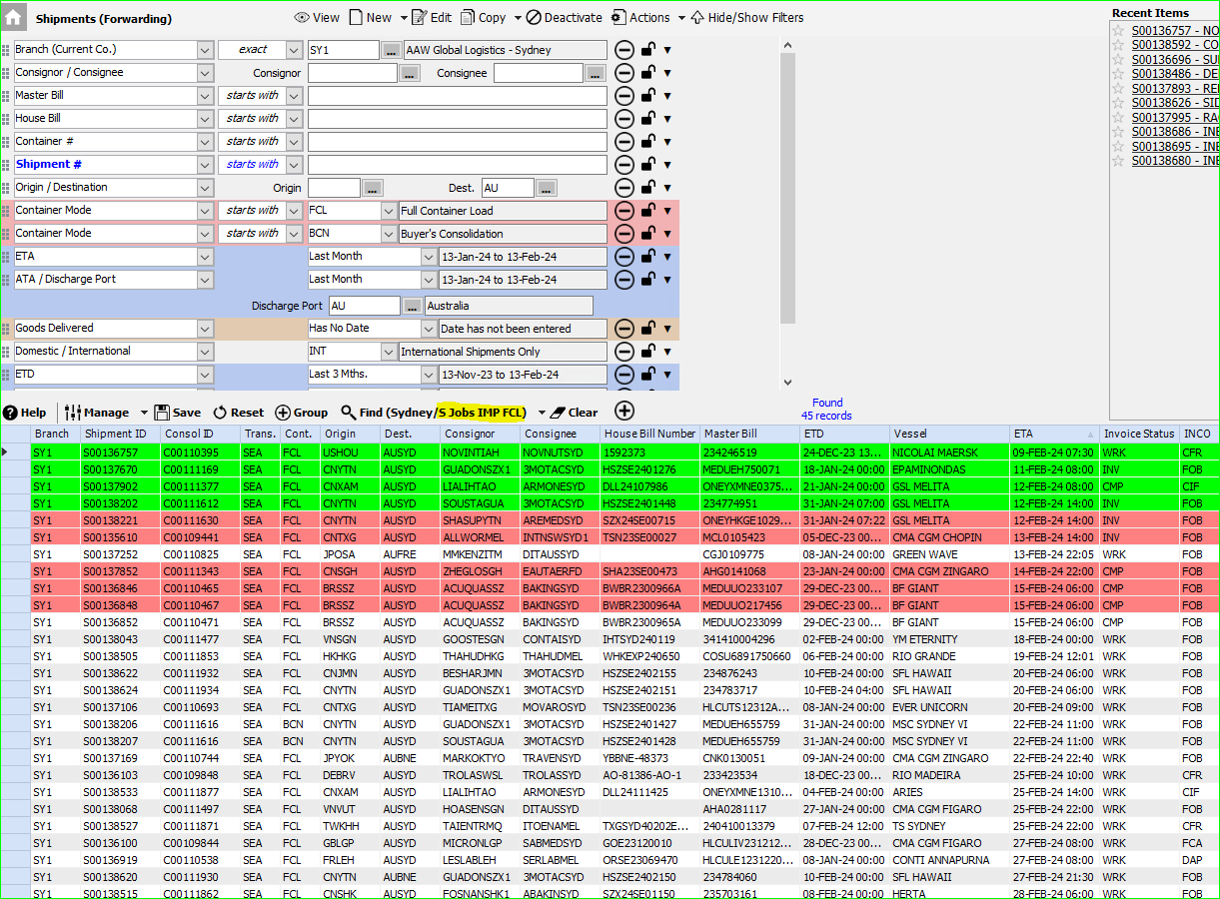

- Following example demonstrates the B Jobs/Import FCL listing, although all other modes are also to be checked.

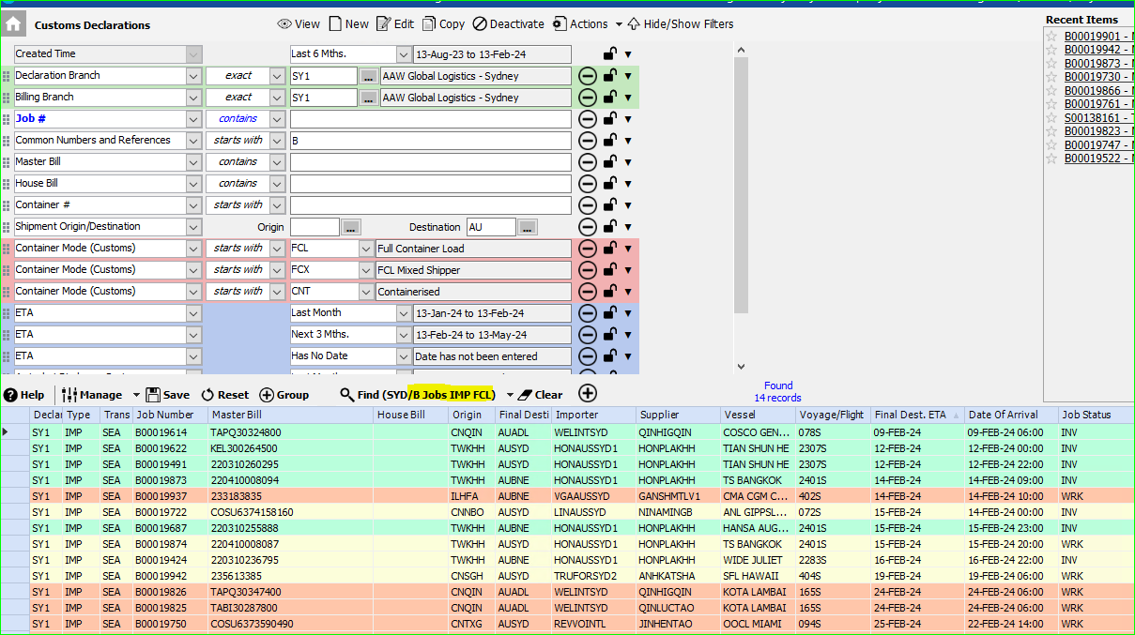

Should you wish to generate an extract for the operator/s showing jobs to focus on, this can
be done by selecting the desired lines then Export All Columns to Excel as per following example.

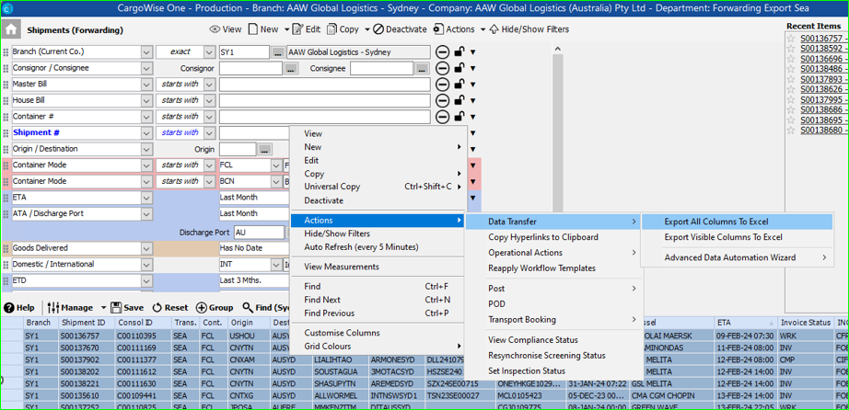

Month End Closing Checks

- This filter shows unbilled jobs with profit, which means job is showing a profit which is likely not correct or for the current month. Therefore, you will need to either invoice these, or put a temporary adjustment accrual in to balance the job profit to zero. 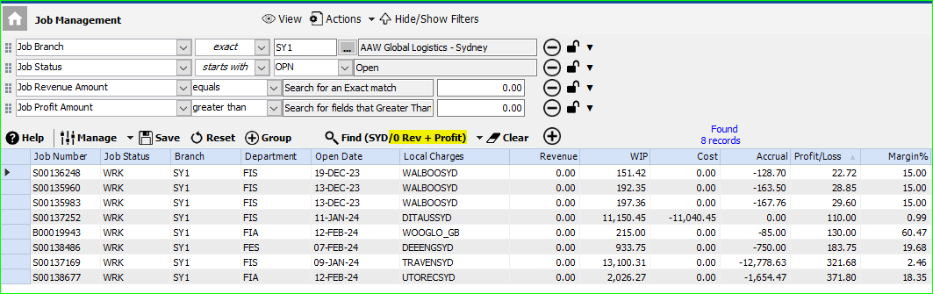

- This filter shows unbilled jobs with losses, which means job is showing a loss which is likely because you have processed costs but not yet billed the job. Therefore, you will need to either invoice these, or put a temporary adjustment accrual in to balance the job profit to zero. 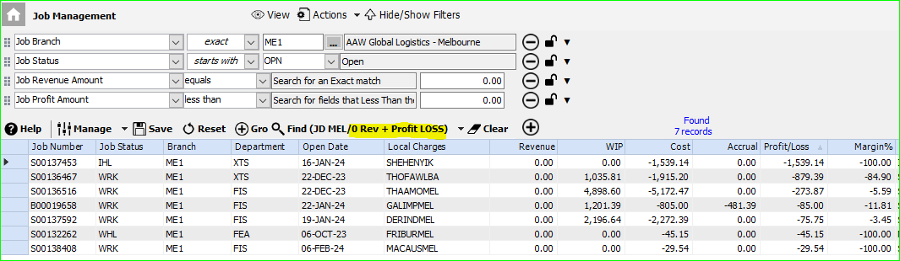

- This filter shows what jobs you have which have outstanding WIPs. Therefore, you need to either invoice these or delete the WIPs or put in a temporary adjustment accrual to balance the job profit to zero.
If the job has already been invoiced, this filter can be used to identify jobs that have WIPs which may have been created in error. For example, if an AP invoice was processed and it generated a duplicate WIP. So best to go through and check if they should be there or not.
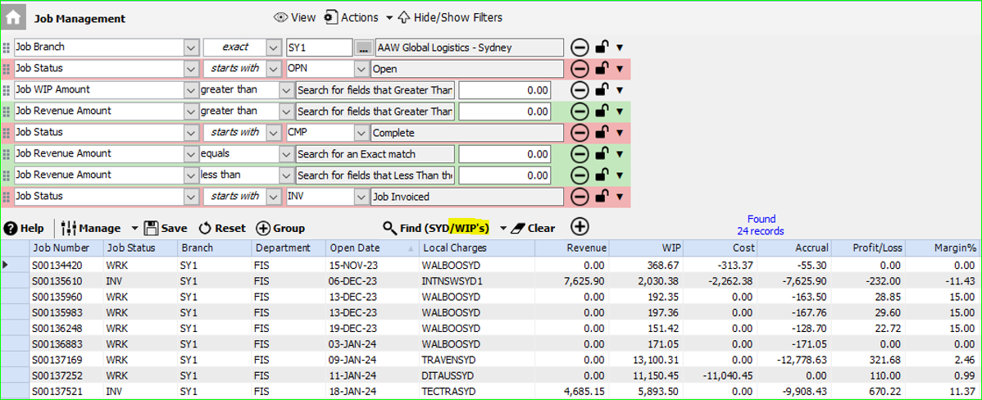

- This filter is the general Job Management screen which shows everything.
This is where we sort and go through the following areas to check for any potential errors or concerns –
- Jobs with extreme profits
- Jobs with low profit/losses
- Jobs with old accruals (older than say 3 plus months)
- Jobs ready to close (when it’s highlighted in green)
This screen can also show you pending WIPs.
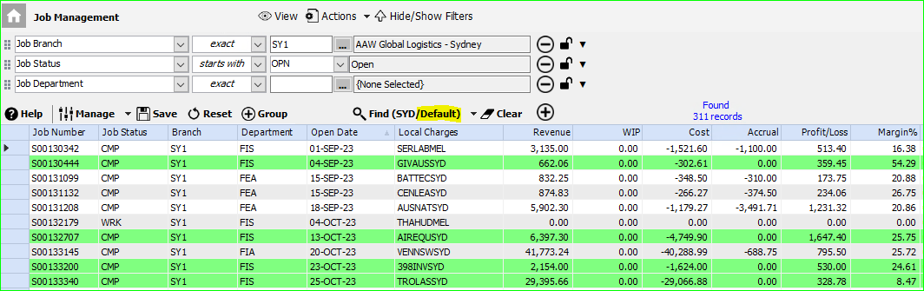

In summary, as follows are the standard set of checks to undertake for each month end closing. Best to check intermittently during the month and then ramp up checks to daily during the last week of the month to allow for time to correct any errors.

- Check Jobs with profit but no revenue, balance profit to zero if not being billed in the current month.
- Check Jobs with losses but no revenue, balance profit to zero if not being billed in the current month.
- Check all WIPS and determine if they require invoicing, or if they are to be removed, or if profit is to be balanced to zero to allow for invoicing in the next month.
- Check jobs with extreme profits or losses to identify any inaccuracies (this can dramatically impact the branch P&L).
- Close jobs at CMP which are in profit and have no pending WIPs or ACRs (jobs will highlight green if they meet this criteria).
- Close sub jobs relating to client consolidation/BCN jobs (they will not highlight green in Job management as there is no profit, so you need to look for them and manually close each).

